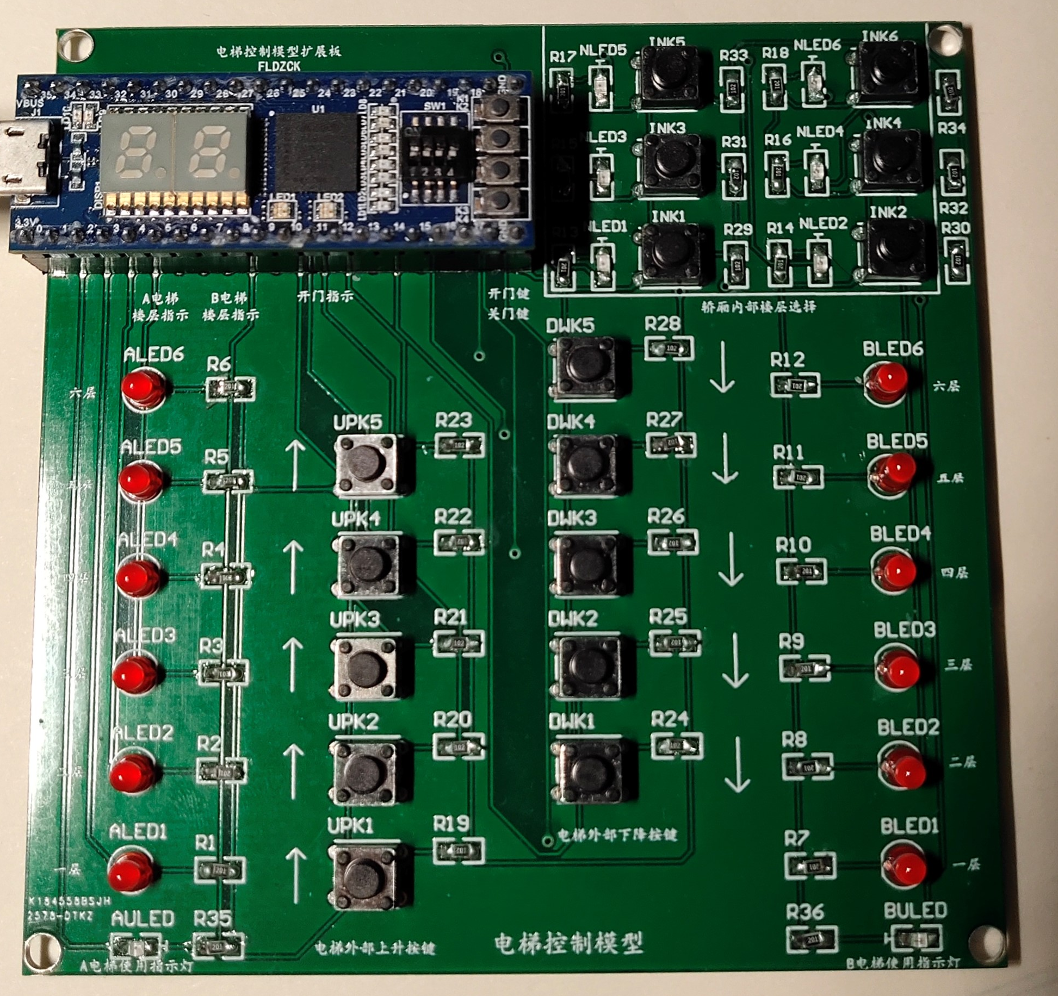
6 floor down button
5 floor up/down button
4 floor up/down button

3 floor up/down button

2 floor up/down button

1 floor up button

Ele-A floor for now
Ele-B floor for now

Ele-A door opening indicator
Ele-B door opening indicator

Ele-A movement indecator

Ele-B movement indecator

Ele-A/B inside panel switch
LED for outside button
Reset
LED for Inside button
Elevator inside button
LED for outside switch

